**LAB-1 Assignment**

**Name:** Bathina, L V Sandeep (16174348)

**1) Design the Class and ER Diagrams using Visio for the InClass Exercise**

1.1 ) Give an E/R diagram involving the Person entity set and all the relationships in which it is involved. Include relationships for mother, father, and children. Extend it with additional relationships such as husband and wife.

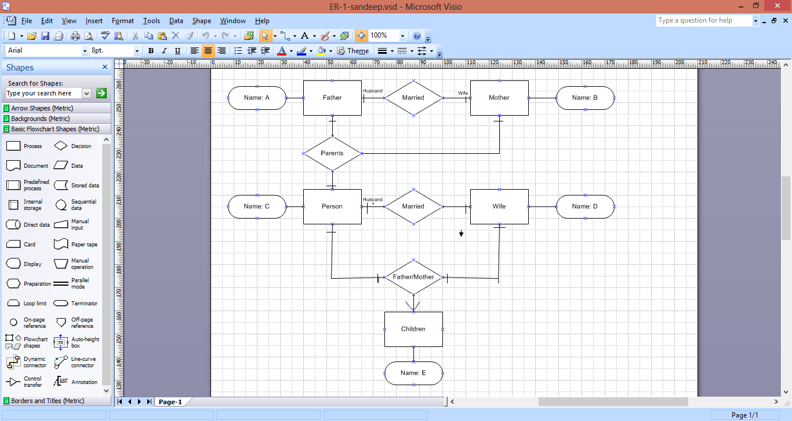

1.2) For the given domain (i.e., Family), define UML Class Diagram that specifies classes and their relationships with specific relationships such as inheritance, aggregation, composition, dependence, association, etc.

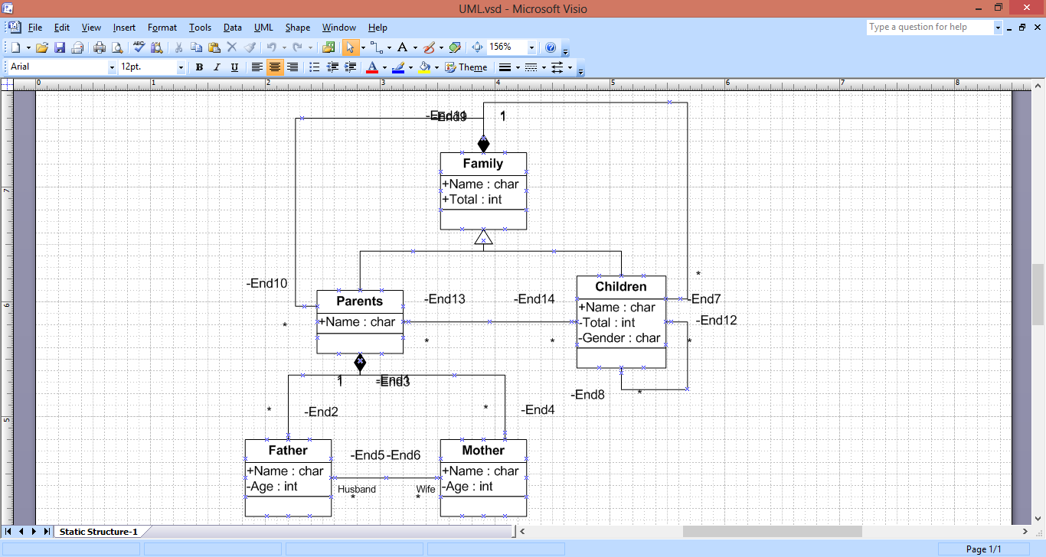

2) **GitHub**

2.1) Create GitHub account and login with the given credentials

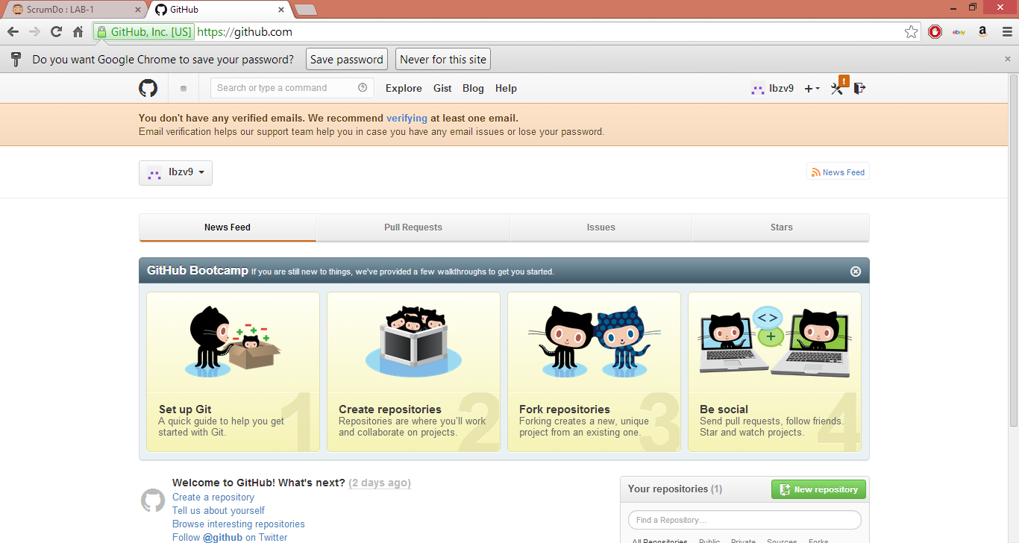

3) **ScrumDo**

3.1) Create ScrumDo account and login with the given username.

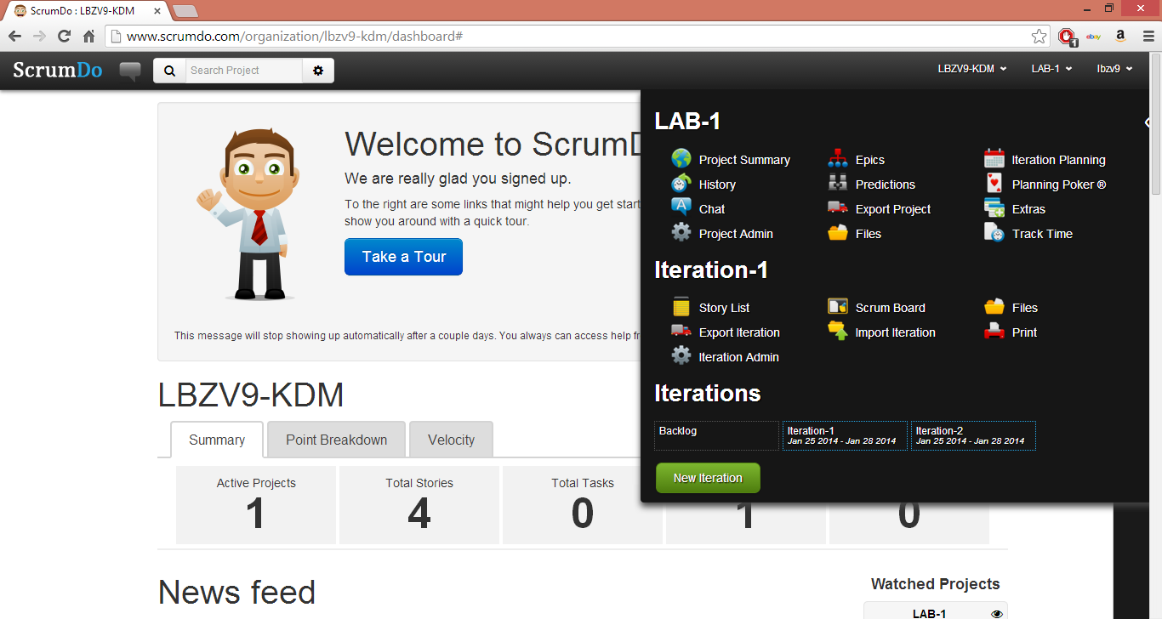

3.2) Define task/plan/delivery for the lab 1 assignment

